1. **Morphological operations based on OpenCV using Morphological Gradient technique**

**Aim:**

To perform morphological operations based on opencv using morphological gradient technique.

**Code:**

import cv2

import numpy as np

img = cv2.imread(r"C:\Users\prith\Documents\CV\cvimage.jpg", cv2.IMREAD_GRAYSCALE)

kernel = np.ones((5, 5), np.uint8)

grad = cv2.morphologyEx(img, cv2.MORPH_GRADIENT, kernel)

cv2.imshow("Original", img)

cv2.imshow("Gradient", grad)

cv2.waitKey(0)

cv2.destroyAllWindows()

**Input:**

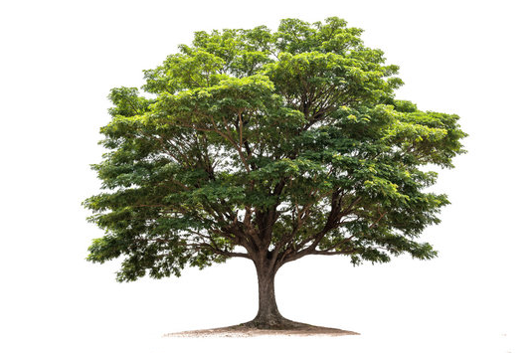

**Output:**

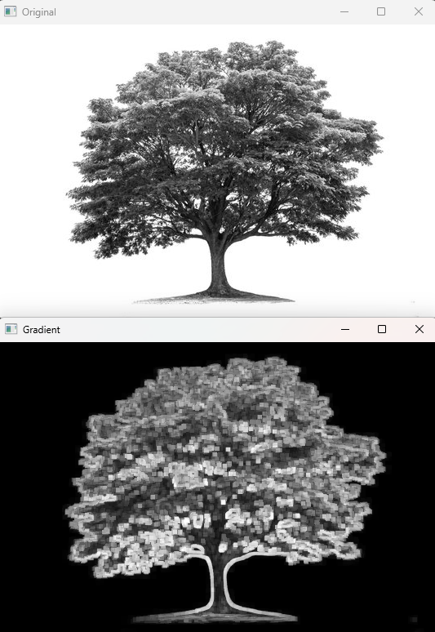

**Result:**

The python code to perform morphological operations based on opencv using morphological gradient technique has been executed successfully.